Capital University of Sciences and Technology



Name: Aiman Bibi
Reg No: BCSP253013
Date: 28/09/2025
QUIZ 01:

Practice Tasks
Practice Task 1:

Step 1: Create simulated auth.log
Create the file with the given log entries:
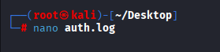

Step 2: Run walkthrough.py to extract information
walkthrough.py script provided in your lab instructions.
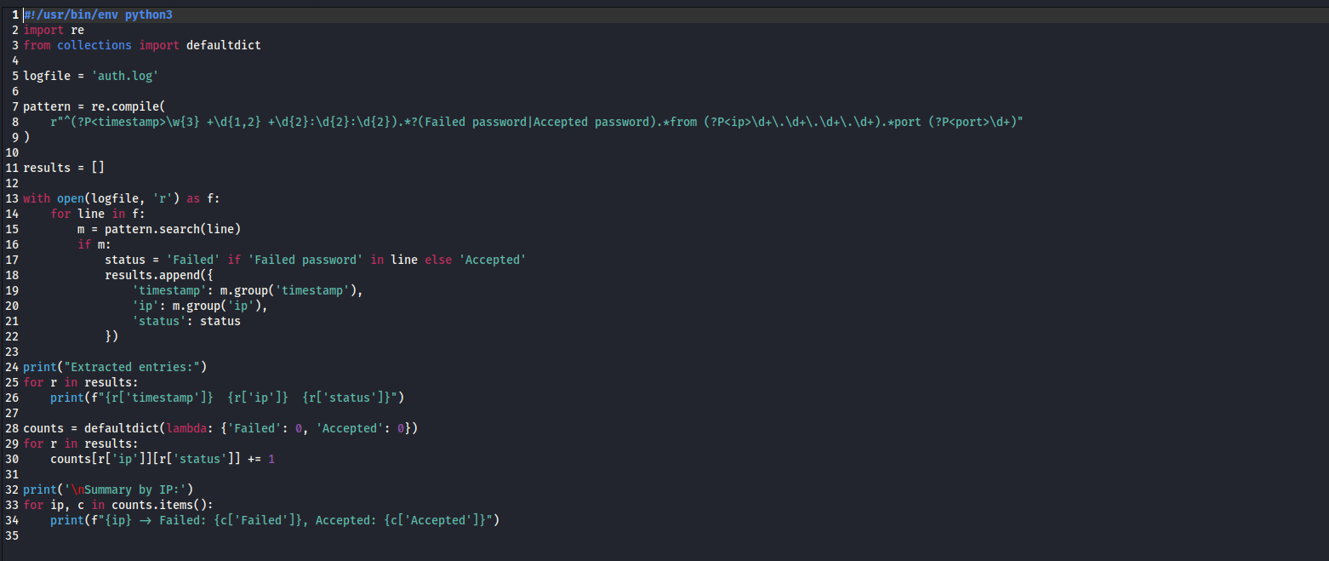
Run it like this:
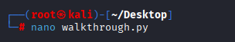

Step 3: Knowledge Summary
Based on the extracted info:
- Data: Raw log entries with timestamps and outcomes.
- Information: IP 192.168.1.100 attempted logins multiple times.
- Knowledge: Two failures followed by a success → pattern of repeated guessing.
- Wisdom: This resembles a brute-force attempt because the attacker kept trying until success.

Step 4: Apply Wisdom (Security Controls)

Protect Confidentiality

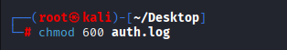

Protect Integrity
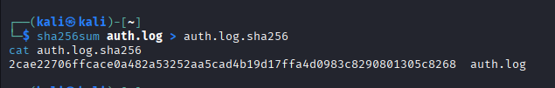

Protect Availability

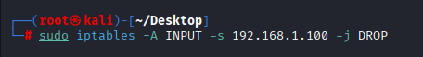

Block the attacker’s IP:
Practice Task 2:
Python Program: temperature_sensor.py
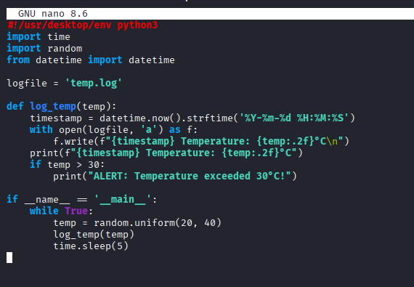
Output:
